Module Assignment 4

* Create an HTML page that will fulfill the following requirements:
  1. There should be 3 inputs, two will take the number, and the third with be dropped down for the operator
  2. There should be a submit button on click that calculates the answer
  3. On change of any input, the answer should be blank and need to click the button again
  4. The answer box should be read-only.
  5. Should use bootstrap and JS for creating the following layout
  6. You can change the text and background color but don’t change the component placement

**ScreenShot:**

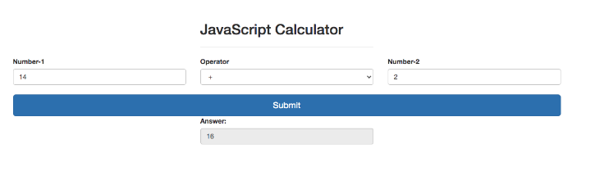

**ScreenShot#1**

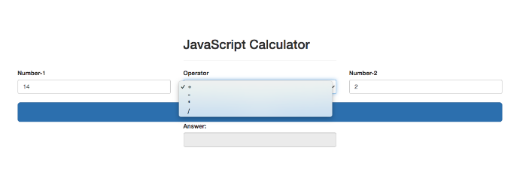

**ScreenShot#2**

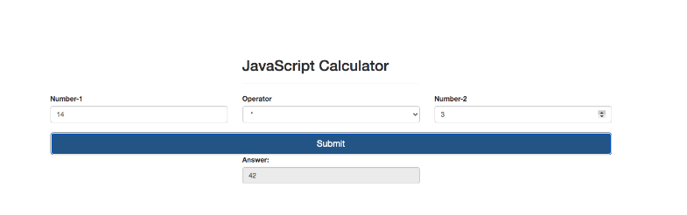

**ScreenShot#3**